**Grafana 101**

**Add Data Source**

Go to <http://localhost:3000/datasources> > Add new data source

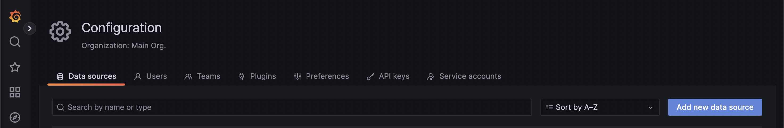

Add data source – Prometheus

HTTP

URL: <http://prometheus:9090>

Save & Test

Add data source – Loki

HTTP

URL: <http://loki:3100>

Save & Test



Add data source – Jaeger

HTTP

URL: <http://jaeger:16686>

Save & Test



**Dashboard**

Go to <http://localhost:3000/dashboards>

**Dashboard – Node Exporter**

<https://grafana.com/grafana/dashboards/15172-node-exporter-for-prometheus-dashboard-based-on-11074/>

**New > Import**

Click Download ID copied! Or Copy ID: 15172

Click Load

Select Prometheus

Click Import

